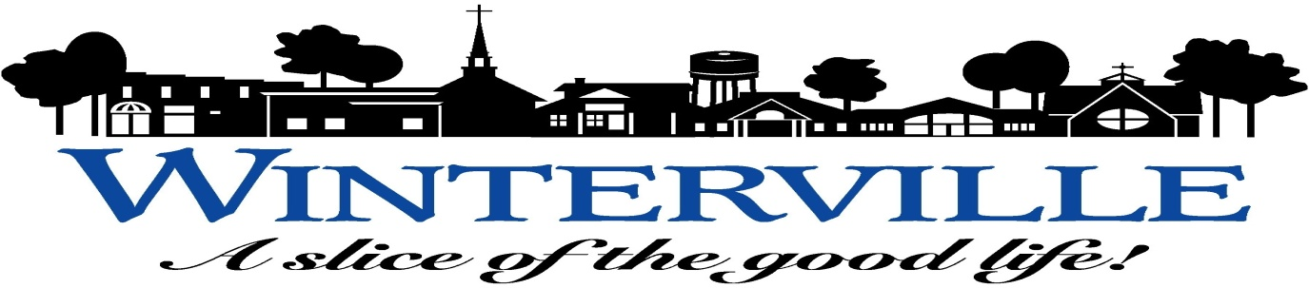
TOWN COUNCIL AGENDA
October 8, 2018 - 7:00 P.M.
WINTERVILLE TOWN HALL ASSEMBLY ROOM
- CALL TO ORDER.
- INVOCATION.
- PLEDGE OF ALLEGIANCE.
- WELCOME.
- APPROVAL OF AGENDA.
- RECOGNITION OF EMPLOYEES:
  - Mike Brown, Building Inspector/Code Enforcement Officer.
  - Alexander Alves, Paramedic.
- PUBLIC HEARINGS:
1. Annexation - Mellon Downs, Ph. 2A and 2B: Lots 19, 21, 25, 40, 41, 45, 47, 49, 50, 52, 57, 73, 74, 75, 83, and 85.
2. Aces for Autism Property (Parcel #14643) Rezoning.

- PUBLIC COMMENT: The Public Comment period of thirty minutes provides an opportunity for residents to comment on any item included in the agenda or to address the Town Council on any other matter related to the Town of Winterville. For an item included in the Public Hearing section of the agenda, residents should address the Council at the time the Mayor invites public comment on the item. No public comment may be made to the Council during the meeting, except during the Public Comment period or as part of a Public Hearing. Individual speakers are limited to a maximum of three minutes, and no more than three speakers may address the Council on a single matter. The Town Council may elect to take no action on the matter addressed by a speaker, may schedule the matter for further consideration at a future Council meeting, or may refer the matter to Town staff for disposition. Copies of the Town Public Comment Policy are available in the rear of the Assembly Room.

- CONSENT AGENDA: The following items are considered routine in nature and will not be discussed by the Town Council unless a Councilman or citizen requests that an item be removed from the Consent Agenda for further discussion. The Mayor may allow citizens to address an item or ask questions.
- Approval of the following sets of Council Meeting Minutes:

- April 9, 2018 Regular Meeting Minutes.
- April 30, 2018 Budget Progress Meeting – FY 2018-2019 Fiscal Year Budget.
- June 11, 2018 Regular Meeting Minutes.
- August 13, 2018 Regular Meeting Minutes.
2. Annexation of Aquaventure (Beacon Drive) – Instruct the Town Clerk to Investigate the Sufficency of Annexation Petition.

- OLD BUSINESS:
1. Engineering Services for 2018 Sanitary Sewer Rehabilitation Project.
2. Purchase of Vac-Con V311E/1300LHAQDA Titan Model Sewer Truck from the NC Sheriffs’ Association.
- NEW BUSINESS:
  - Request from Bill Clark Homes for Roll Curb instead of Standard Curb in the Eli’s Ridge Subdivision.
- OTHER AGENDA ITEMS.
- ITEMS FOR FUTURE AGENDAS/FUTURE WORK SESSIONS.
  - Workshop Date for Discussion on Purchase of Pre-Tax Natural Gas.
- REPORTS FROM DEPARTMENT HEADS:
Update on Projects Currently Underway: Regional Sewer Pump Station Project
Chapman Street Culvert - Nobel Canal Drainage
Basin Study
2018 SRF Application (Sewer Rehabilitation)
NTE Plant Construction Project
Minimum Housing/Code Enforcement
Horizon Land Use Plan
Multi-Purpose Building Site Plan
Winterville Market/Town Common Plan
Resurfacing of the Hillcrest Basketball Courts
Fork Swamp Greenway Project

- REPORTS FROM THE TOWN ATTORNEY, MAYOR AND TOWN COUNCIL, AND TOWN MANAGER.

- ANNOUNCEMENTS:
  - Planning and Zoning Board Meeting – October 15, 2018 – 7 pm – Town Hall Assembly Room.
  - Board of Adjustment Meeting – October 16, 2018 – 7 pm – Town Hall Assembly Room.
  - November Regular Council Meeting has been moved to Tuesday, November 13, 2018 due to the Veteran’s Day Holiday.

XVIII. ADJOURN.

SPECIAL NOTICE: Anyone who needs an interpreter or special accommodations to participate in the meeting should notify the Town Clerk, Don Harvey at 215-2344 at least forty-eight (48) hours prior to the meeting. (Americans with Disabilities Act (ADA) 1991.)

