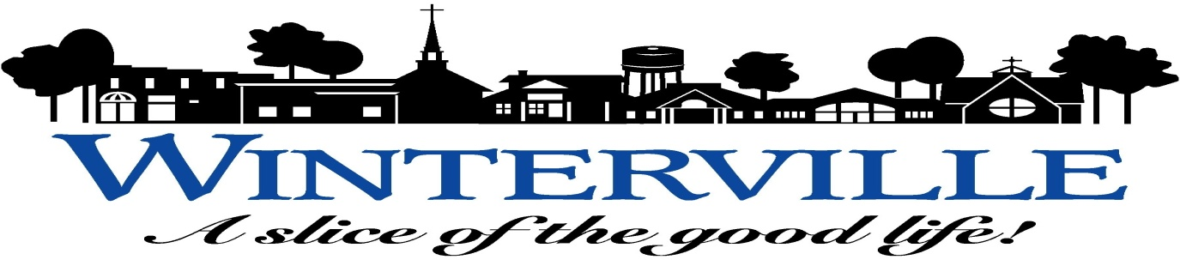
TOWN COUNCIL AGENDA
SPECIAL CALLED MEETING - MARCH 19, 2018 - 6:00 P.M.
WINTERVILLE TOWN HALL EXECUTIVE CONFERENCE ROOM
- CALL TO ORDER.
- INVOCATION.
- WELCOME.
- APPROVAL OF AGENDA.
- CLOSED SESSION: NCGS § 143-318.11. (a)(3) To consult with an attorney employed or retained by the public body in order to preserve the attorney-client privilege between the attorney and the public body, which privilege is hereby acknowledged. General policy matters may not be discussed in a closed session and nothing herein shall be construed to permit a public body to close a meeting that otherwise would be open merely because an attorney employed or retained by the public body is a participant. The public body may consider and give instructions to an attorney concerning the handling or settlement of a claim, judicial action, mediation, arbitration, or administrative procedure. (Natural Gas Agreement with GUC).

- ITEMS FOR DISCUSSION:
  - Staff Report on the First Two Months (2018) of the Power Purchase Agreement (PPA) with NTE Carolinas, LLC.
- OTHER AGENDA ITEMS (verbal updates):
  - Report on Petition for Reduction of Speed Limit and Installation of Speed Bumps on Gaylord Street. (Councilman Moore)
  - Update on Requests for Signs in and around Town. (Councilman Moore)
  - Update on Possible Cable Coverage of Town Meetings. (Councilman Moore)

- REPORTS FROM DEPARTMENT HEADS:
Update on Projects Currently Underway: Fork Swamp Greenway Project
Regional Sewer Pump Station Project
Nobel Canal Drainage Basin Study
Water Tank Rehabilitation Project
NTE Plant Construction Project

- REPORTS FROM THE TOWN ATTORNEY, MAYOR AND TOWN COUNCIL, AND TOWN MANAGER.

XVIII. ADJOURN.

SPECIAL NOTICE: Anyone who needs an interpreter or special accommodations to participate in the meeting should notify the Acting Town Clerk, Amy Barrow at 215-2342 at least forty-eight (48) hours prior to the meeting. (Americans with Disabilities Act (ADA) 1991.)

